# Language Detection Web Application – Duck Soft Works § Co.

# US 5 - As an administrator I want to be able to query, create and delete categories that do not yet have associated tasks.

## 1. Requirements Engineering

### 1.1. Customer Specifications and Clarifications

1:

**Q:** Will the categories be determined by the administrator? Can they be deleted? If yes, will the administrator be able to delete all of them or should there be one by default, the administrator will not be able to delete them?

**A:** The basic categories (**economics, philosophy, mechanics, nutritionism and sport**) cannot be eliminated

2 :

**Q:** Can we consider a "Default" Category as one of the base categories, thus preventing it from being deleted or changed as well?

**A:** Consider one of the base categories to be the default category

### 1.2 Customer Specifications and Clarifications

**From the specifications document:**

The text categories correspond to areas of interest (e.g. economics, philosophy, mechanics,

nutritionism, sport).

### 1.3. Acceptance Criteria

The name of Categories to be created must not be composed only by special characters, numbers or empty or just blank

### 1.4. Found out Dependencies

There is no direct dependency in the creation of a Category, as it can exist alone.

To delete a Category, it is necessary that they were already created. Also, it is impossible to delete a category that is part of the 5 base bootstrap created categories.

### 1.5 Input and Output Data

To create a category, it’s necessary to indicate the name with the appropriate format already described.

To search it’s not necessary to indicate anything as it always returns all categories in the system.

To delete it’s necessary to indicate the name of what Category wants to delete. The user receives a message that states the (un)success of the operation.

### 1.6. System Sequence Diagram (SSD)

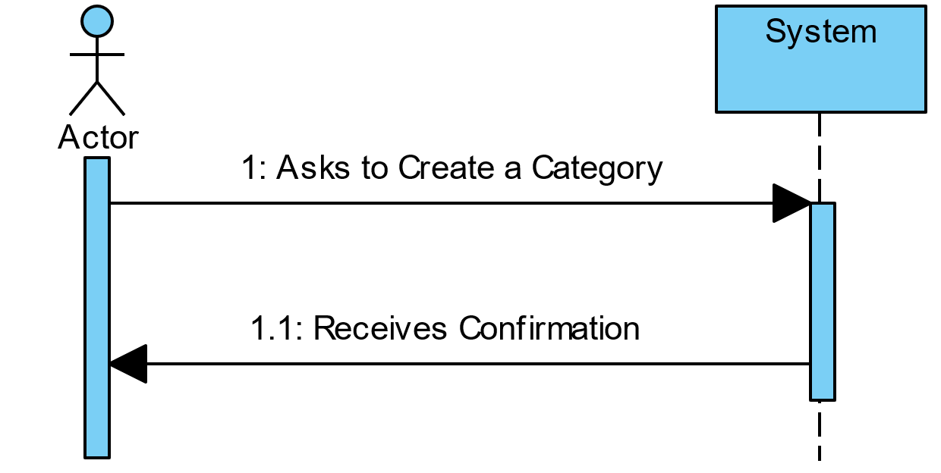

## 2. OO Analysis

### 2.1. Relevant Domain Model Excerpt

## US 5 - Category Domain Model

## 3 Sequence Diagram (SD)

**Create a Category Diagram**



**Delete a Category Diagram**

### Generic - Delete

**Find all Category Diagram**



## 3.1 Class Diagram (CD)



## Tests

Tests if it is possible to create a category with the same name as a base category.

@Test  
public void ensureCategoryNameIsNotCreatedWithOnlyNumbers*(){* String categoryName = "123456789";  
  
 IllegalArgumentException illegalArgumentException = *assertThrows(*IllegalArgumentException.class, *()* -> *{* new CategoryName*(*categoryName*)*;  
 *})*;  
  
 Assert.*assertEquals(*illegalArgumentException.getMessage*()*, "Impossible to create category name"*)*;  
*}*

*}*

@Test  
public void ensureCategoryNameIsNotCreatedWithOnlySpecialCharacters*(){* String categoryName = "$%&/(/&%&/(/&%$))#$€";  
  
 IllegalArgumentException illegalArgumentException = *assertThrows(*IllegalArgumentException.class, *()* -> *{* new CategoryName*(*categoryName*)*;  
 *})*;  
  
 Assert.*assertEquals(*illegalArgumentException.getMessage*()*, "Impossible to create category name"*)*;  
*}*

# Construction (Implementation)

The construction of the Category lacks information and feedback from the client, as seen in questions at the beginning of this document. Some restrictions to names of the category were inferred by common sense, as the client described the categories as areas of interest. As also asked by the client 5 categories are added by bootstrap at the start of the application and cannot be changed by any means. Furthermore as determined by the client we choose Philosophy as default Category when no category is provided to a task.

# Integration and Demo

In the future the Category class can integrate all kinds of different tasks related to the application, organizing, and delimiting as asked by the client.

In the frontend, the admin user must be logged in to be able to perform the said actions.

Insert a new Category:

Delete a Category:

Trying to Delete a base Category:

# 

# 7. Observations

It is necessary to verify with the client if the already implemented limitations to category creation are enough and if they work to meet the client’s expectations.